**Analysis On Best Neighborhood In Ahmedabad City (India) For Opening A Specialty Pizza Outlet**

By Rushikesh R. Mokashi

11/19/2020

|  |
| --- |
| **Table of Contents** |
| 1. IntroductionIntroduction |
| 2. Data Requirement, Acquisition and Cleaning |
|  |
|  |

1. **Introduction**

**1.1 About The City [1]**

**Ahmedabad** (also spelled **Ahmadabad**) was founded by King Karandev 1 in the 11th century and originally called "Karnavati". The Hindu kingdom of Karnavati ruled for more than 400 years until 1411 when Sultan Ahmed Shah conquered Gujarat and the city was renamed Ahmedabad after him.

Ahmedabad is the sixth largest city (pop. 6.5 million) in India, and it's India's first UNESCO World Heritage City. It is the commercial hub of the state of Gujarat. The city was built in open and spacious plains to the East of Sabarmati. Ahmedabad was a cradle of the non-violent movement for India's independence, being host to the Sabarmati ashram of Mahatma Gandhi.

Ahmedabad is a gastronomic paradise. You will find at least one restaurant in every nook and corner, anywhere in Ahmedabad. Gujarati people are fond of eating and the food generally tends to be on the sweeter side. Ahmedabad is famous for its ice-creams because of abundance of dairy products in the state and Gujaratis' penchant for sweets as well.

If you have not stayed in India for long, select a food place which is famous and well organized (hotels, big restaurants). Otherwise, its fun to eat at one of the road side stalls, especially at the Khau Galli in Law Garden area and Khan Pan Bazaar in Manek Chawk. Various stalls start operating in both these places in the evening and run late in the night. You will enjoy the food like Paani - Puri (Gol Gappa), Indian Chat, Indian Sandwiches, North Indian, Indian-Chinese and some continental cuisines, amazingly at road-side stalls and for a very reasonable price of less than a US$1 per item.

**1.2 The Problem At Hand**

As an investor who wants to invest in a restaurant business and open a specialty pizza restaurant in the city, that serves a wide range of pizza choices. The investor would like to explore the neighborhoods within the city and find out places that would be most profitable with less competition.

**1.3 Interested Stakeholders**

Anyone who is interested in exploring the neighborhoods of Ahmedabad city with a view of starting a pizza outlet in the city.

**2.** **Data Requirement,** **Acquisition and Cleaning**

**2.1 Data Required**

The problem at hand requires us to explore different neighborhoods around the city and understand various places of interest around each of these neighborhoods. In order to do this we would need the following data.

* + - 1. A list of all the neighborhoods
      2. Geo-spatial data of these neighborhoods
      3. Places of interest around each of the neighborhoods

**2.2 Data Sources**

No ready-to-use dataset was available for the purpose of this analysis. Data has been acquired from variety of sources. The postal codes for listing different neighborhoods in the city and the geo-co0rdinate data was available from [www.geonames.org](http://www.geonames.org/).[2] The places of interest data was gathered using Foursquare APIs. Some of the missing geo-spatial data was collected using Nominatim Library and rest had to be manually entered using google maps.

**2.3 Data Cleaning**

After downloading the data file from [www.geonames.org](http://www.geonames.org/), only data pertaining to Ahmedabad city was selected and copied to another file. Since the geo-spatial data available in the file was for the postal code and not for the individual neighborhood, only the neighborhoods were selected from the file.

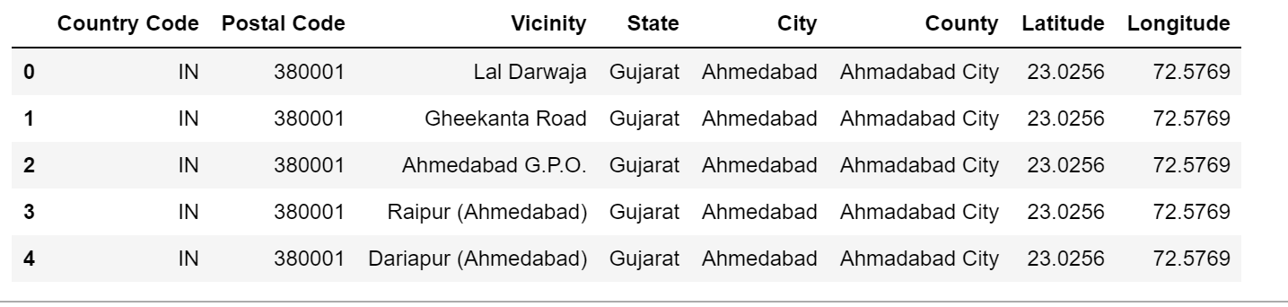

Once all the neighborhood data was available, the Geo-spatial data was collected by iterating through the neighborhoods and getting location data from geocoder library Nominatim. This data along with the neighborhoods was saved in a .csv file.

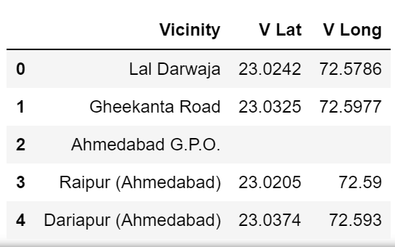

Once this .csv file was obtained, the missing location data for a select few neighborhoods in the Ahmedabad city county were manually input in the file using google maps.

For the purpose of this study only 50 neighborhoods were selected. These are as follows:

|  |  |
| --- | --- |
| 1. Lal Darwaja 2. Manek Chowk 3. Shahibag 4. Sabarmati 5. Kabir Chowk 6. Motera 7. Ambawadi (Ahmedabad) 8. Ellisbridge 9. Paldi (Ahmedabad) 10. Sarkhej Road 11. Anandnagar (Ahmedabad) 12. Shardanagar 13. Narayannagar 14. Jawahar Chowk 15. Maninagar 16. Ashram Road 17. Darpan Society 18. Gujarat University 19. Navrangpura 20. Stadium Marg 21. Vadaj 22. Naranpura Vistar 23. Shastrinagar (Ahmedabad) 24. Nava Vadaj 25. Navjivan | 1. Jodhpur Char Rasta 2. I I M 3. Manekbag 4. Polytechnic (Ahmedabad) 5. Azad Society 6. Meghaningar 7. Gita Mandir Road 8. Civil Hospital 9. Gandhi Ashram (Ahmedabad) 10. Jivraj Park 11. Memnagar 12. Thaltej Road 13. Bodakdev 14. Juhapura 15. Bopal 16. Ghuma 17. Ambli 18. Shela 19. Thaltej 20. Shilaj 21. Sola 22. Bhadaj 23. Ognaj 24. Ghatlodia 25. Sola H B C |

Based on the location data collected for the above neighborhoods, places of interests for each of the above neighborhoods were collected using the FoursquareTM APIs ([www.foursquare.com](http://www.foursquare.com/)). Using the available API, I explored different venues within a radius of 1000 meters / 1 KM.

Following is a snapshot of the data gathered via the API.

[1]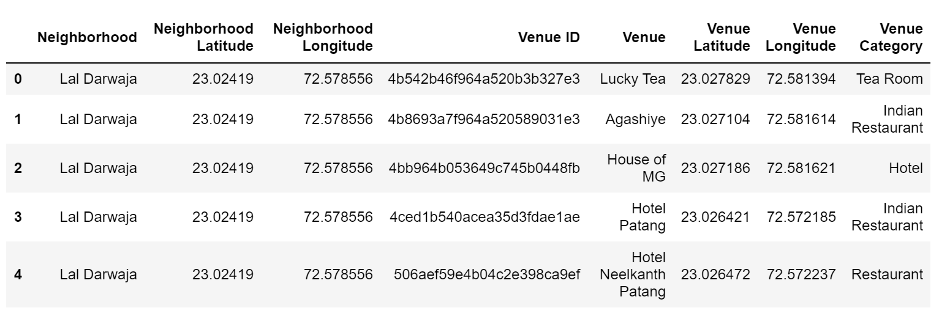References:

[1] https://wikitravel.org/en/Ahmedabad

[2] This work is licensed under a Creative Commons Attribution 3.0 License. See http://creativecommons.org/licenses/by/3.0/

1.